**“Living Canvases” (English, grade 9)**

**Student’s Worksheet**

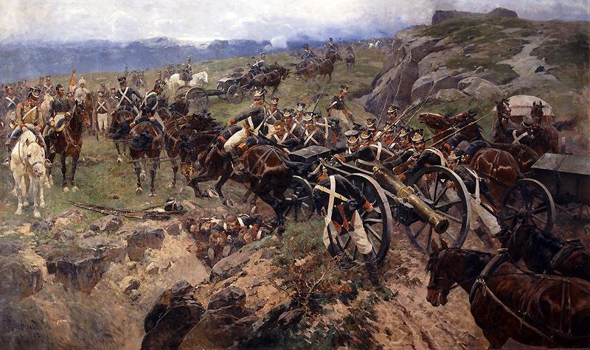**Episode 1. The start of the exhibition**

**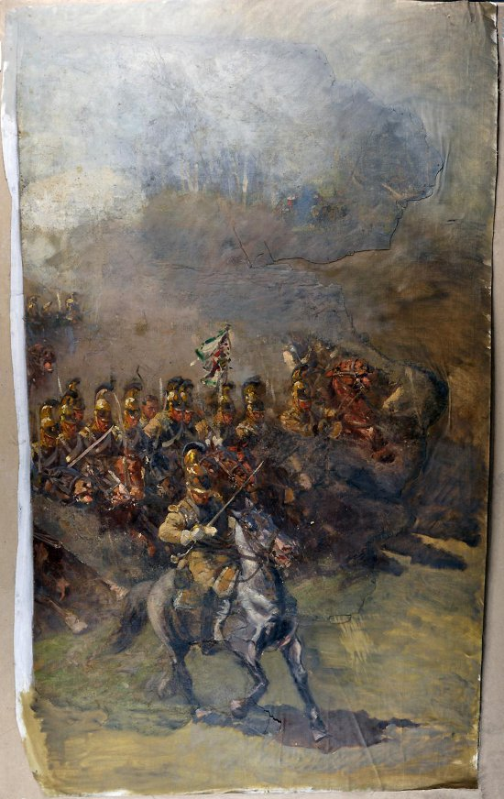*Task 1A.*** *We are now at the start of the exhibition. It opens with a cannon and two paintings*.*

*What genre would you say they belong to? Use the pattern below to make up three words and choose the right answer.*

**A scape** is a view or picture of a scene, usually used in combination, e.g. **a landscape** (https://www.merriam-webster.com/).

1. A picture of a city — ______________________________________

2. A picture of a sea — ______________________________________

3. A picture of a battle — ______________________________________

***Task 1B.*** *What do we call these genres in Russian? Why isn’t the collocation “батальный пейзаж” used in Russian? Use the fact below to deduce the answer.*

The Russian word “пейзаж” originates from the French “pays” [pɛ'i:] — “land, territory”. ⇒ __________________________________________________________

____________________________________________________________________

***Task 2.*** *How do you think the battlescape appeared, and what are its main features? Read the text and form the right words (make all the necessary grammatical changes). Match the passages with the questions they answer. There is one extra question.*

1. Which Russian artists are famous for their battle scenes?

2. How did battle scenes illustrate religious truths?

3. What objects could battle scenes be placed on?

4. Whose work made a revolution in the battle genre?

5. What challenge do battle scene painters face?

6. How did the battle genre develop in the 18th–19th centuries?

Battle Scenes

A. The battle genre is a trend in the visual arts that describes battle scenes. The themes of such paintings cover the causes, course and results of military conflicts, and the works themselves are filled with (1) (emotion) __________ impressions and action. The artists who paint battle scenes are forced to maintain a fine line between the actual (2) (present) __________ of real events and their own artistic (3) (interpret) _________________.

B. The genre has existed since ancient times: battle scenes can be found on the ancient Roman (4) (triumph) __________ arches and Greek vases, praising the heroes. Roman mosaics and wall (5) (paint) __________ of ancient Egypt have brought to this day the history of the conquest of fortresses, cities and battle scenes.

C. In the Middle Ages, artists used the battle theme to illustrate combats between good and evil, in particular, the image of Archangel Michael fighting the devil embodied in a dragon.

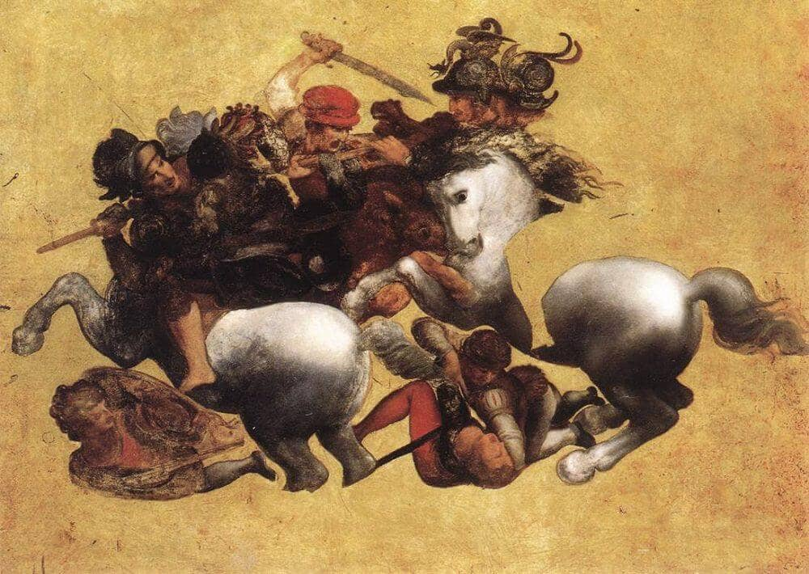D. Renaissance artists brought new ways of depicting the human figure and cavalry battle. Art critics believe that Leonardo da Vinci’s “The Battle of Anghiari” became a turning point in the understanding of the whole idea of battle painting.

E. Paintings with battle scenes from the time of Napoleon Bonaparte were intended mainly for public buildings and reached especially (6) (impress) __________ dimensions. The artists painted not only (7) (victory) _________ battles, but also the suffering of the wounded and the grief. Also, drawings which depicted the soldiers of different countries and types of troops with a detailed image of their uniforms became popular. In Russia, military paintings became popular under Peter I. The artworks were (8) (tradition) __________ patriotic, praising the courage and fighting spirit of the Russian army.

|  |  |  |  |  |
| --- | --- | --- | --- | --- |
| A | B | C | D | E |
|  |  |  |  |  |

***Task 3.*** *Which Russian artists are famous for their battle scenes? One of them is the author of both the paintings we have seen. Read the text, fill in the gaps with the words from the box and say if the information below is true, false or not stated in the text. Make conclusions about the meanings of the words you do not know.*

plot pit Academy panoramic purchased detachment retreating

The painting “The Living Bridge” was created in 1897, and was first presented at the spring exhibition of 1898 at the Imperial (1) __________ of Arts in St. Petersburg.

The (2) __________ is based on the events of the Russo-Persian War (1804–1813). A small (3) __________ under the command of Colonel [ˈkɜːnəl] Karyagin was (4) __________ under the attack of the Persian army which was 10 times larger. On the way there was a deep (5) __________, across which it was necessary to carry two cannons that the detachment had. The soldiers threw themselves to the bottom of the pit, built a bridge with their bodies and saved both the cannons and the detachment.

“The Living Bridge” made a great impression on Emperor Nicholas II, and he ordered the painting to be (6) __________ for the Winter Palace.

“The Horsemen” were painted in 1912 and used to be part of the original (7) __________ painting “The Battle of Borodino”.

The author of both paintings is Franz Roubaud [ruːˈbɔː] (1856–1928).

1. Both the paintings show the events of the Patriotic War of 1812. ___

2. One of the paintings shows a heroic deed of the Russian soldiers. ___

3. Both the paintings were created by an artist of the French origin. ___

**Episode 2. The Green Hall**

***Task 4.*** *Before we talk about the central painting of the museum and its author, let us pay attention to more battle scenes. Find the paintings below in the hall and match them with their names.*

|  |  |
| --- | --- |
| A. https://panoramaborodino.museum-online.moscow/api/spf/QGdRMdWsUhHZv3ZklUO6QV994Hjw3kULYtKLZkEnJKVkLpyjsonUhYIYl0hQlEzJ.jpg?w=650&h=800 | 1. The Feat of Raevskii’s Soldiers at Saltanovka |
| B. https://panoramaborodino.museum-online.moscow/api/spf/A2EP7E6nG9HBBmkTMGC9cJOFZ7UI6Qvk8OleXrhJKOt0dmO2rd9tjhTl6mJ0lOjk.jpg?w=1450&h=900 | 2. Fight for the Banner. The Feat of Horse Guards Gavrilov and Omelchenko at Austerlitz |
| C. https://panoramaborodino.museum-online.moscow/api/spf/UpDok-W386W6OOtUD0xPL0jttD0-3j1EEseTlV3-G0Df8aggcO4onG7Sjx5rYz8u.jpg?w=1150&h=900 | 3. The Battle for Smolensk |
| D. https://panoramaborodino.museum-online.moscow/api/spf/o9ZIpOMZhGGdZFXF5LJPF-2BsbswMB1iXM00v6NmBw2xlcD9R0VTliG4Daa1CGa5.jpg?w=1450&h=900 | 4. Pursuit of French Mounted Rangers by Horse Guards near Polotsk on August 6th, 1812 |
| E. https://panoramaborodino.museum-online.moscow/api/spf/bN8zI176kuCHhRWYBJIhd4mzSqOyWG6cwJnxJBnmumsnjobWYWMSrh3OJx5oloYd.jpg?w=1300&h=900 | 5. Attack of the Lithuanians |

|  |  |  |  |  |
| --- | --- | --- | --- | --- |
| A | B | C | D | E |
|  |  |  |  |  |

***Task 5.*** *Match the adjectives from the chart with the feelings they describe. The glossary may help you.*

|  |  |
| --- | --- |
| A. Miserable, heartbroken, gloomy, frustrated, regretful | 1. Pride |
| B. Furious, enraged | 2. Confidence |
| C. Baffled, stupefied, bewildered, perplexed | 3. Fear |
| D. Petrified, terrified, panicky, anxious | 4. Shock |
| E. Calm, hopeful, confident, relieved, inspired | 5. Anger |
| F. Proud, dignified, triumphant | 6. Sadness |

|  |  |  |  |  |  |
| --- | --- | --- | --- | --- | --- |
| A | B | C | D | E | F |
|  |  |  |  |  |  |

***Task 6.*** *Look at the list of features and tick (V) the ones that you believe to be common for the five paintings above and any other battle scenes in the hall. Share and explain your ideas using the questions below and the adjectives from Task 5. The information from Appendix may help you.*

|  |  |
| --- | --- |
|  | Heroic pathos |
|  | Demonstration of glorious victories |
|  | Depicting panic, frustration and misery |
|  | Demonstration of large-scale and epic events |
|  | Detail, realism, historical authenticity, portrait-like images |
|  | Dynamism and intensive action |
|  | Drama and high intensity of emotions |
|  | Deep ideological content and symbolism |
|  | Regret about the tragedies of war and personal fate |

* What is happening in the picture?
* Who is shown in the picture?
* What do you think the characters’ feelings are?
* How does the artist show the dynamics of the battle?

**Episode 3. The Battle of Borodino**

***Task 7.*** *Who created the panoramic painting “The Battle of Borodino”? What is the history of the painting, and why do we see a part of it at the entrance to the exhibition? Read the text and choose the correct options. Only one answer is correct.*

Who was Franz Roubaud, and to which national school of painting his art belongs? Franz Roubaud was born into a French family in Odessa, and kept his French citizenship until 1914. French was his mother’s tongue. His surviving correspondence allows us to see that Roubaud’s Russian was good. Over the course of his many years living in Munich, the artist acquired good German. In the Roubaud household in Munich, Italian was also sometimes spoken. Finally, we must assume some knowledge of Polish also: as a young man Roubaud spent some time in Poland. But, nevertheless, Roubaud referred to himself as a Russian artist, “…I was born in Russia and lived there for more than 22 years, it is where I received my education, I paint exclusively pictures of Russian day-to-day and military life; all these signs suggest that I should be considered a Russian artist”.

In 1909, Russia was preparing to celebrate the anniversary of the victory in the Patriotic War of 1812. The members of the anniversary committee addressed Roubaud, a friend of Ilya Repin and a well-known artist, with a proposal to paint a panorama for the centenary of the Battle of Borodino.

In 1910, Roubaud traveled to Moscow and visited for the first time the battlefield at Borodino. His first sketches for the panorama “The Battle of Borodino” were presented to the Tsar on September 23rd. Roubaud stayed in close contact with experts in Russian military history.

In 1911, Roubaud lived in St. Petersburg. On March 8th, he signed an official contract to paint the panoramic painting “The Battle of Borodino”. General B. M. Kolyubakin, historian and teaching professor, was appointed the official advisor to Roubaud to guarantee historical precision. Roubaud created the panoramic painting in Munich. For his research he traveled to Berlin, Paris, Moscow and to the battlefield of Borodino in August.

In less than a year, Roubaud completed the panorama. In May 1912, it was exhibited for five days in Munich before it was sent to Moscow. On August 29th, the panorama was exhibited in a special wooden pavilion in Chystoprudnii Boulevard. The wooden pavilion was temporary, and there were plans to build a stone one. Unfortunately, the roof could not protect the painting from heavy rain, and it was damaged by water.

In 1914, the World War I started, and after the Revolution of 1917, the pavilion was brought down. The 115-metre panorama was kept as a roll in several unsuitable places.

It was only after the Great Patriotic War the painting was examined. Its condition was so poor that few artists believed anything but a few fragments could be kept. However, restorers headed by Pavel Korin saved the painting. Several new elements, like the wounded Prince Bagration, were added.

The current building of the museum was opened in 1962, for the 150th anniversary of the victory in the Patriotic War of 1812. It is situated on the territory of the former village Fili, where the historic military council headed by M. I. Kutuzov took place.

1. What was Franz Roubaud’s primary artistic affiliation, according to his own words?

A) French artist

B) German artist

C) Russian artist

D) Polish artist

2. What role did General B. M. Kolyubakin play in the creation of the panorama?

A) He financed the project.

B) He acted as Roubaud's official advisor to ensure historical accuracy.

C) He painted additional elements of the panorama.

D) He organized the exhibition in Munich.

3. Where did Franz Roubaud create the panoramic painting?

A) St. Petersburg

B) Moscow

C) Munich

D) Paris

4. What caused significant damage to Roubaud’s “The Battle of Borodino” panorama after its exhibition in Moscow?

A) Fire

B) Heavy rain

C) Vandalism

D) War-related destruction

5. What significant change was made to the panorama during its restoration after the Great Patriotic War?

A) The entire panorama was repainted from scratch.

B) The painting was reduced in size to fit a smaller exhibition space.

C) New elements, such as the wounded Prince Bagration, were added.

D) The panorama was divided into smaller sections for separate displays.

***Task 8.*** *Look at the panorama and use the digital terminals to say if the following information is true or false.*

1. The panorama shows the advance of the French army from the east. ___

2. The panorama actually shows the village Borodino. ___

3. Both Napoleon and M. I. Kutuzov are present in the painting. ___

4. One of the roads shown in the picture leads to Moscow. ___

5. The Streamlet Semenovskiy served as a natural frontline between the armies. ___

**Episode 4. The Yellow Hall**

***Task 9.*** *We are at the peak of the 1812 War. Read two texts and put the verbs in the correct forms. Find the pictures the passages describe. Write down the names of the pictures.*

In the centre of the square we see Emperor Napoleon accompanied by his generals. They (1) (to look) __________ in confusion at the panorama of the famous Moscow fire. The situation depicted could only have happened on September 16th, 1812. On this day, the fire (2) (to reach) __________ its greatest proportions. Shortly after 4 p.m., when the flames began to seriously threaten the Kremlin, the French emperor left. The small figures of conquerors against the background of a grandiose fire clearly (3) (to demonstrate) __________ confusion.

Name: _____________________________________________________________

The artist Aleksei Danilovich Kivshenko created the painting as an illustration to the description to the famous novel “War and Peace” by L. N. Tolstoi. Following Tolstoi, he (4) (to interest) __________ not so much in the historical accuracy of the details as in the psychological authenticity of the behavior of the Council participants.

Many repetitions and copies of the painting made during the artist's lifetime (5) (to know) __________. Before us is one of such copies, painted by a student of A. D. Kivshenko, with the personal permission of the author.

L. N. Tolstoi described the course of the military council as it could have been seen by the fictional character of the novel — the 6-year-old daughter of the owner, Malasha, “Malasha timidly and joyfully looked down from the stove at the faces, uniforms and crosses of the generals 6. (to enter) __________ the hut one by one and sitting down on the wide benches under the icons.”

Name: _____________________________________________________________

**Episode 5. The Red Hall**

***Task 10.*** *Let us talk about the final stages and the outcomes of the Patriotic War of 1812. Find the paintings below in the hall and match them with their names. Return to Task 6 and do the same. How do the battle scenes in this hall differ from the scenes in the Green one?*

|  |  |
| --- | --- |
| A. https://panoramaborodino.museum-online.moscow/api/spf/QGdRMdWsUhHZv3ZklUO6QWriuH8OM-nmNVkgoehXzLS4kZWwhyYsCXzWb12lKzZU.jpg?w=800&h=600 | 1. The French Army Crossing the Berezina |
| B. https://panoramaborodino.museum-online.moscow/api/spf/QGdRMdWsUhHZv3ZklUO6QQkwfUxanBlNgMkm-uoksmE8T-YnBZmqyMf-aEe7xcun.jpg?w=800&h=700 | 2. The Feat of Colonel Nikitin's Battery in the Battle near Krasnoie, 1812 |
| C. https://panoramaborodino.museum-online.moscow/api/spf/QGdRMdWsUhHZv3ZklUO6Qcl7UVQbJmDcfSZdPAvetKCDn-aRpzC9IMSVovw_MYGd.jpg?w=800&h=550 | 3. Napoleon's Return from the Campaign against Russia |

|  |  |  |
| --- | --- | --- |
| A | B | C |
|  |  |  |

|  |  |
| --- | --- |
|  | Heroic pathos |
|  | Demonstration of glorious victories |
|  | Depicting panic, frustration and misery |
|  | Demonstration of large-scale and epic events |
|  | Detail, realism, historical authenticity, portrait-like images |
|  | Dynamism and intensive action |
|  | Drama and high intensity of emotions |
|  | Deep ideological content and symbolism |
|  | Regret about the tragedies of war and personal fate |

* What is happening in the picture?
* Who is shown in the picture?
* What do you think the characters’ feelings are?
* How does the artist convey the characters’ feelings? Can we find any symbolic elements in the paintings?

***Task 11.*** *Do the Case Task.*